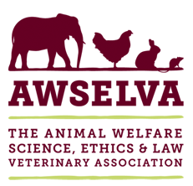
Strategy Day Agenda
Committee Room, Langford House, Bristol Veterinary School, Langford, BS40 5DU

Tuesday 14 May 2019

10.00 Welcome to the Strategy Day Paul Roger
10.05 Introductions Liz Genever
10.25 Summary of survey Liz Genever
10.45 Who is our target audience? (group discussion)
11.00 Break
11.15 What are our messages? (small group discussion)
12.00 What do we want AWSELVA to be doing in five years’ time?
12.30 Lunch, including EGM
13.30 What do we want AWSELVA to be doing in five years’ time? (cont)

14.45 What do we need to do first? (group discussion)
15.45 Summary of decisions
16.00 Strategy day closes

